Home

gani938 edited this page a minute ago · [1 revision](https://github.com/gani938/LAB2/wiki/Home/_history)

**Pages 1**

* [**Home**](https://github.com/gani938/LAB2/wiki)

[Add a custom sidebar](https://github.com/gani938/LAB2/wiki/_new?wiki%5Bname%5D=_Sidebar)

**Clone this wiki locally**



[**Clone in Desktop**](x-github-client://openRepo/https:/github.com/gani938/LAB2.wiki)

**Objective**

To create a mashup web application.

**Feature**

1. OAuth login from facebook
2. Create About page, Contact page and mashup pages for displaying weather information and calorie information
3. Mashup page with
4. check JS cpde using JSlint tool.

**Steps**

1. create appId for facebook login and enable it in the profile setting. So that OAuth login can be used using facebook.
2. Create Edamam's ApplicationId and key for using recipi apis.
3. create login and signup pages.
4. create navigation bar with pages of home, about, contact, weather, calories.
5. Using angular controller, make these pages as components so that each page can render independently.

**Initial Page**

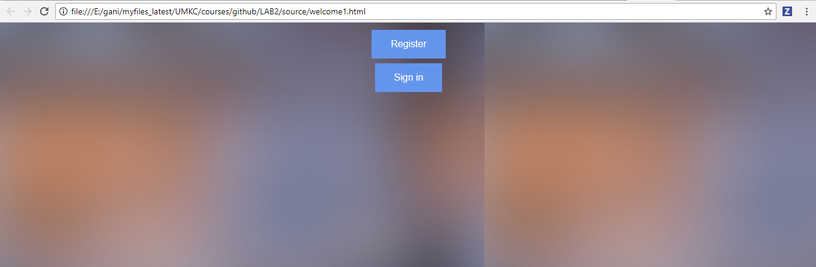

**Register page**

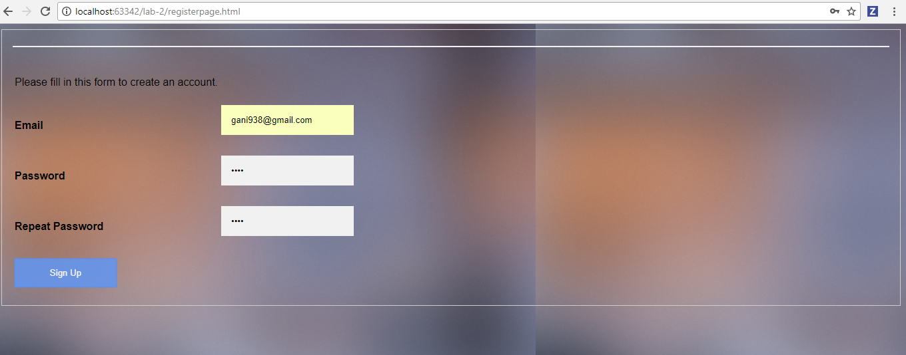

**Registered User SignIn page**

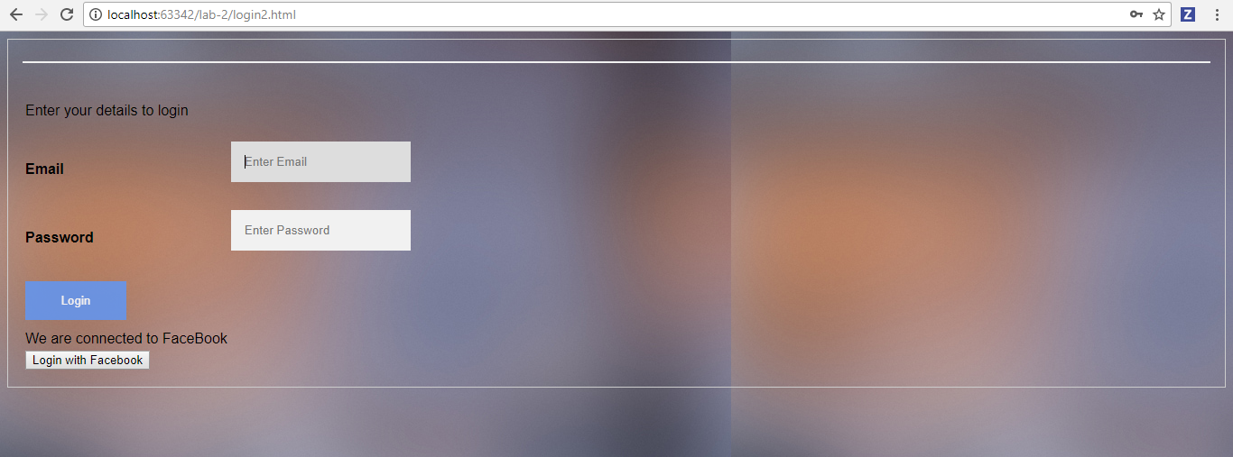

**Facebook User SignIn page**

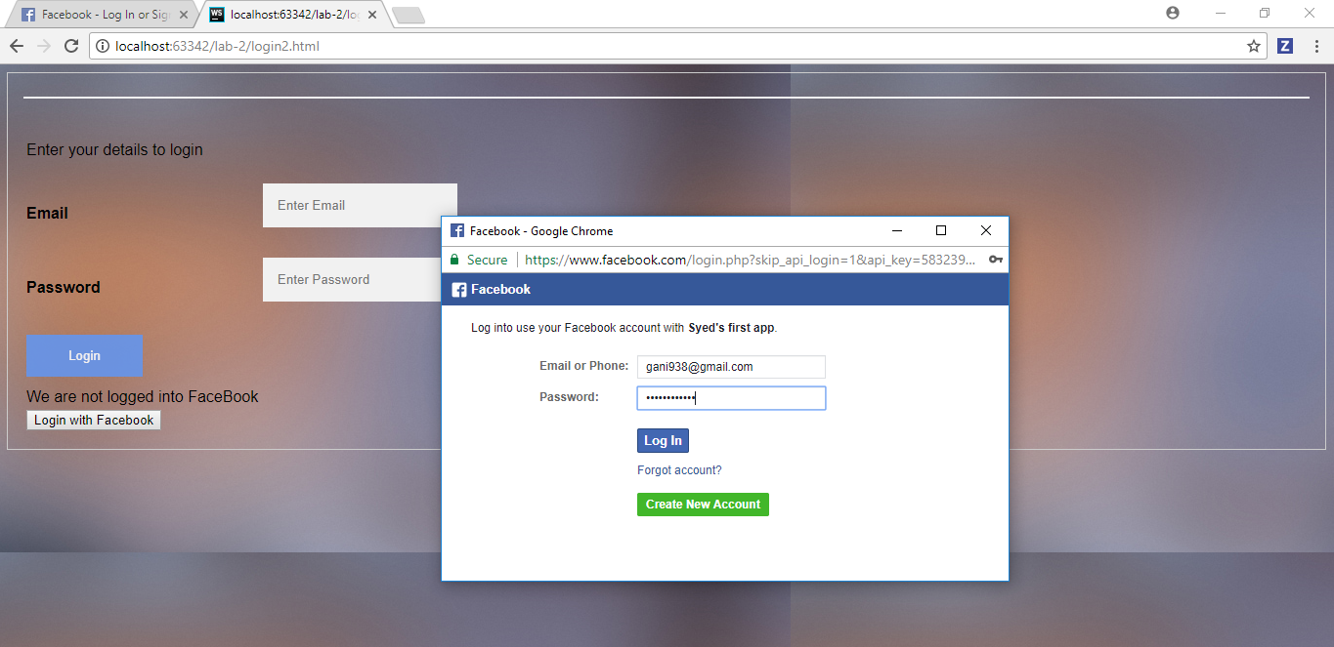

**Home page**

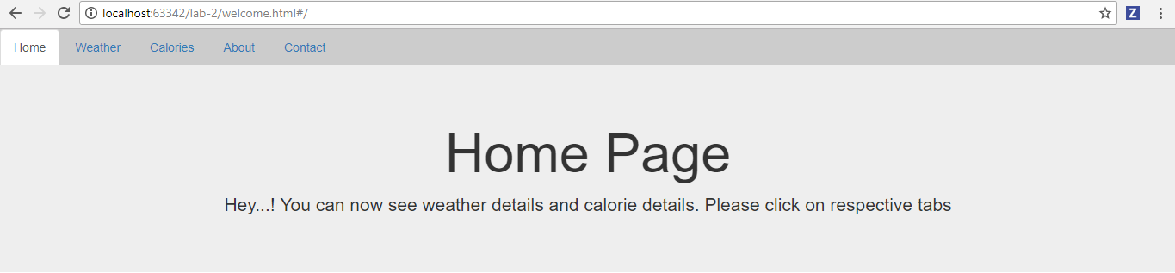

**Weather Information page**

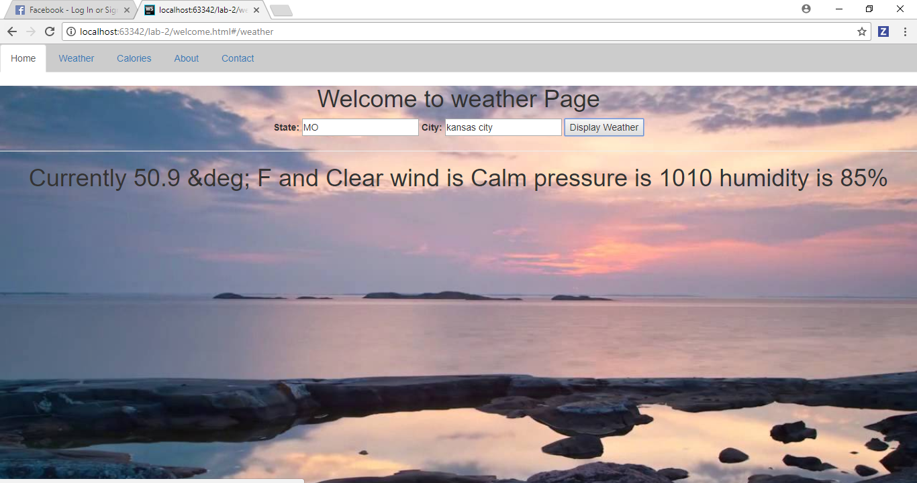

**Calories Information page**

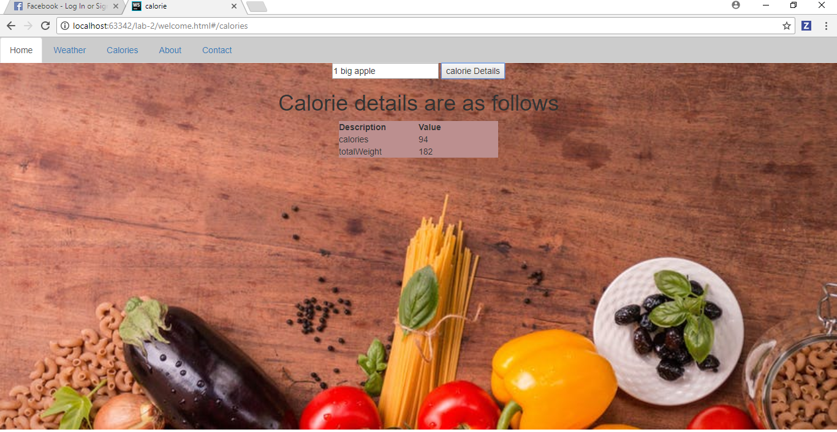

**About page**

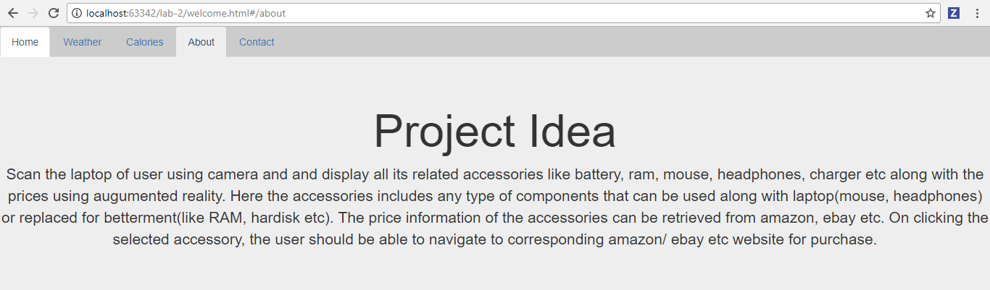

**Contact Page**

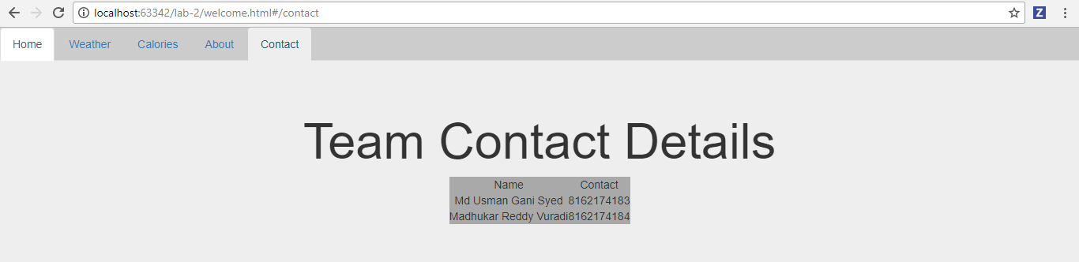

**Jslint**

